* REGISTRATION PAGE

1. **Privacy agreement**

* Customer service Icon

1. Change ID log in password
2. Retrieve ID password
3. Game problems

* LOG IN PAGE

1. Forgot password
2. Same customer service same as registration page

* AFTER LOG IN

1. welcome notification popup
2. First deposit POPUP( first deposit details page inside activity tab which is available in activity section ( first recharge activity))

* Home Page

1. Notification page inside the detail tab

Wingo game

1. Notification page inside the detail tab
2. How to play POPUP
3. Win and Loss POPUP
4. Withdrawal and Deposit

K3 GAME

1. How to play POPUP
2. Win and Loss POPUP
3. Withdrawal and Deposit

5D Game

1. How to play POPUP
2. Withdrawal and Deposit
3. Win and Loss POPUP

TRX WINGo

1. How to play POPUP
2. Win and Loss POPUP
3. Withdrawal and Deposit
4. Public chain query
5. Block height question mark Under game history

BASIC TOOLS

1.Notification Icon

2. Customer service Icon

3. Beginner’s Guide

ABOUT US

1.confidentiality agreement

2.Risk Disclosure agreement

4. Download app

WHEEL SPIN ICON

1. Event description
2. Event details
3. Activity rules

* PROMOTION PAGE

1. New subordinates page inside Subordinate Icon
2. Invite page inside invitation link tab
3. Subordinate data page inside subordinate data tab
4. Commission detail page inside commission detail tab
5. Promotion rule page inside invitation rules tab
6. Agnet Line customer service page inside the customer service tab
7. Rabate ratio page inside rebate ratio tab
8. Customer service icon for self customer service center

* ACTIVITY PAGE

1. Invitation reward Page inside invitation reward icon ( will be available in big daddy game )

1. Invitation reward Rules page inside the invitation reward rules

2. Invitation record page inside the invitation record page

1. Activity Reward page inside the Activity Reward page icon
2. Rebate page inside the betting rebate icon

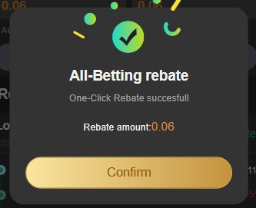

1. Gift page inside the gifts tab
2. Attendance Page inside the Attendance bonus tab

1. Game Rules Page inside the Game rule tab

2. Attendence history page inside Attendence History Tab

6. Activity Pages inside the Activity Tabs

* WALLET PAGE

1.Recharge page inside the deposit tab

* deposit history page inside the deposit history tab

2. withdraw Page inside the withdraw tab

* withdraw history page inside the withdraw history tab

* add bank card details page inside the add a bank account number tab

* add usdt address page inside the add address tab

3. Deposit history page inside the deposit history icon

4. withdraw history page inside the withdraw history icon

*ACCOUNT

1. AR wallet API page inside AR wallet icon

2. Recharge page inside the deposit tab

* deposit history page inside the deposit history tab 1

3. withdraw Page inside the withdraw tab

* withdraw history page inside the withdraw history tab

* add bank card details page inside the add a bank account number tab

* add usdt address page inside the add address tab

4.VIP page inside the VIP icon

5. Safe page inside the safe tab

* Safe history page inside the all history tab

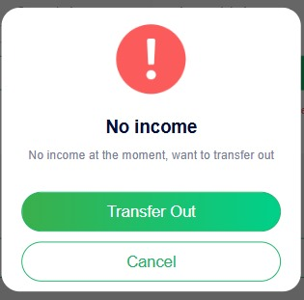

6.bet History page inside the Game history icon

7. transection history page inside the transection icon

8. deposit history page inside the deposit icon

9. withdraw history page inside the withdraw icon

10. notification page inside the notification tab

11. gift page inside the gifts tab

12. game statistics page inside the game statistics tab

13. seetings center page inside the setting icon

* change login password page inside login password tab

* bind mailbox page inside the bind mailbox tab

14. feedback page inside the feedback icon

15. notification page inside the notification icon

16. customer service page inside the customer service icon

17. beginner’s guide page inside the beginner’s guide icon

18. about us page inside the about us icon

* Confidentiality agreement page inside the Confidentiality agreement tab

* risk disclosure Agreement page inside risk disclosure Agreement tab

Customer Service Pages